ACE-CL-312

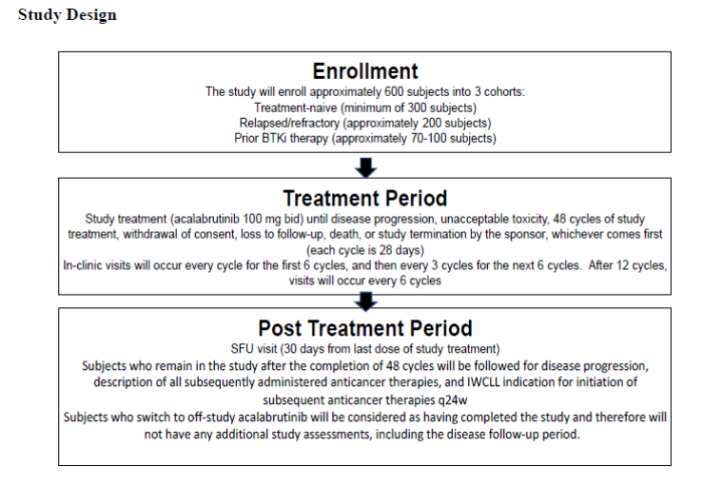

Inclusion criteria
1. Men and women ≥18 years of age (or the legal age of consent in the jurisdiction in which the study is taking place)
2. Diagnosis of CLL that meets published diagnostic criteria (Hallek et al. 2018):
a. Monoclonal B-cells (either kappa or lambda light chain restricted) that are clonally co-expressing ≥1 B-cell marker (CD19, CD20, and CD23) and CD5
b. Prolymphocytes may comprise <55% of blood lymphocytes
c. Presence of ≥5 × 109 B lymphocytes/L (5000/^L) in the peripheral blood (at any point since the initial diagnosis)
3. Active disease as per at least 1 of the following IWCLL 2018 criteria
a. Evidence of progressive marrow failure as manifested by the development of, or worsening of, anemia (hemoglobin <10 g/dL) and/or thrombocytopenia (platelets <100,000/^L)
b. Massive (i.e., ≥6 cm below the left costal margin), progressive, or symptomatic splenomegaly
c. Massive nodes (i.e., ≥10 cm in the longest diameter), progressive, or symptomatic lymphadenopathy
d. Progressive lymphocytosis with an increase of >50% over a 2-month period or a lymphocyte doubling time (LDT) of <6 months. LDT may be obtained by linear regression extrapolation of absolute lymphocyte count obtained at intervals of 2 weeks over an observation period of 2 to 3 months. In subjects with initial blood lymphocyte counts of <30x109/L 30,000/^L), LDT should not be used as a single parameter to define indication for treatment. In addition, factors contributing to lymphocytosis or lymphadenopathy other than CLL (e.g., infections) should be excluded.
e. Autoimmune anemia and/or thrombocytopenia that is poorly responsive to standard therapy
f. B-symptoms documented in the subject’s chart with supportive objective measures, as appropriate, defined as ≥1 of the following disease-related symptoms or signs:
o Unintentional weight loss ≥10% within the previous 6 months before screening
o Significant fatigue (Eastern Cooperative Oncology Group [ECOG] performance status ≥2; inability to work or perform usual activities)
o Fevers higher than 100.5°F or 38.0°C for ≥2 weeks before screening without evidence of infection
o Night sweats for ≥1 month before screening without evidence of infection
4. Must meet 1 of the following criteria:
a. Have received no prior therapy for treatment of CLL and meets 1 of the following criteria:
i. A score of >6 on the Cumulative Illness Rating Scale (CIRS)
ii. Creatinine clearance of 30 to 69 mL/min using the Cockcroft-Gault equation
b. Have previously received therapy for CLL and have either refractory or relapsed CLL
c. Have received prior BTKi therapy (i.e., defined as a subject who discontinued a BTKi for any reason except disease progression) for CLL
5. ECOG performance status of ≤2
6. Female subjects of childbearing potential (i.e., not surgically sterile or postmenopausal) who are sexually active with a non-sterilized male partner must use ≥1 highly effective method of contraception from the time of screening and must agree to continue using such precautions for 2 days after the last dose of study treatment. Contraception measures and restrictions on sperm donation are not required for male subjects. See Appendix F for guidance and definitions for reproduction and contraception.
7. Fluorescence in situ hybridization (FISH) within 60 days before or during screening reflecting the presence or absence of del(17p), 13q del, 11q del, and trisomy of chromosome 12 along with the percentage of cells with the deletion, along with TP53 sequencing. Subjects must also have molecular analysis to detect IGHV mutation status at any time point since diagnosis.
8. Each subject (or legally authorized representative if allowed per local regulations) must be willing and able to adhere to the study visit schedule, understand and comply with other protocol requirements, and provide written informed consent and authorization to use protected health information.

Exclusion criteria
1. Subjects who have had disease progression while on a BTKi for any malignant or nonmalignant condition
2. Prior malignancy (other than CLL), except for adequately treated basal cell or squamous cell skin cancer, in situ cancer, early stage prostate cancer, or other cancer from which the subject has been disease-free for ≥2 years
3. History of confirmed progressive multifocal leukoencephalopathy
4. Significant cardiovascular disease such as symptomatic arrhythmias, congestive heart failure, or myocardial infarction within 6 months before screening, or any Class 3 or 4 cardiac disease as defined by the New York Heart Association Functional Classification, or corrected QT interval using Fridericia’s formula (QTcF) >480 msec at screening. Note: Subjects with rate-controlled, asymptomatic atrial fibrillation are allowed to enroll in the study.
5. Malabsorption syndrome, disease significantly affecting gastrointestinal function, resection of the stomach, extensive small bowel resection that is likely to affect absorption, symptomatic inflammatory bowel disease, partial or complete bowel obstruction, or gastric restrictions and bariatric surgery, such as gastric bypass
6. Evidence of active Richter's transformation. If Richter’s transformation is suspected (i.e., lactate dehydrogenase [LDH] increased, asymmetric fast lymph node growth or clinical suspicion), it should be ruled out with positron emission tomographycomputed tomography (PET-CT) and/or biopsy according to guidelines
7. Central nervous system (CNS) involvement by CLL
8. Known history of human immunodeficiency virus, serologic status reflecting active hepatitis B virus or hepatitis C virus infection, any uncontrolled active systemic infection along with subjects who are on ongoing anti-infective treatment and subjects who have received vaccination with a live attenuated vaccine within 4 weeks before the first dose of study treatment
a. Subjects who are hepatitis B core antibody (anti-HBc) positive and who are hepatitis B surface antibody (anti-HBs) negative will need to have a negative hepatitis B virus PCR result before enrollment. Those who are hepatitis B surface antigen (HBsAg) positive or hepatitis B virus PCR positive will be excluded.
b. Subjects who are hepatitis C virus antibody positive will need to have a negative hepatitis C virus PCR result before enrollment. Those who are hepatitis C virus PCR positive will be excluded
9. Uncontrolled autoimmune hemolytic anemia or idiopathic thrombocytopenic purpura defined as declining hemoglobin or platelet count secondary to autoimmune destruction within the screening period or requirement for high doses of steroids (>20 mg daily of prednisone or equivalent for longer than 2 weeks)
10. History of stroke or intracranial hemorrhage within 6 months before the first dose of study treatment
11. History of bleeding diathesis (e.g., hemophilia or von Willebrand disease)
12. Presence of a gastrointestinal ulcer diagnosed by endoscopy within 3 months before screening
13. Major surgical procedure within 4 weeks before first dose of study treatment. Note: Subjects who have had major surgery must have recovered adequately from any toxicity and/or complications from the intervention before the first dose of study treatment.
14. Requires treatment with proton-pump inhibitors (e.g., omeprazole, esomeprazole, lansoprazole, dexlansoprazole, rabeprazole, or pantoprazole). Subjects receiving proton-pump inhibitors who switch to H2-receptor antagonists or antacids are eligible for enrollment in this study.
15. All subjects requiring or receiving anticoagulation with warfarin or equivalent vitamin K antagonists (e.g., phenprocoumon) within 7 days before first dose of study treatment.
16. Absolute neutrophil count (ANC) <0.50 x 109/L or platelet count <30 x 109/L, unless proven due to CLL and raised above the limits by granulocyte colony-stimulating factor (G-CSF) therapy and/or pooled platelet transfusion
17. Total bilirubin >3.0x upper limit of normal (ULN); or aspartate aminotransferase or alanine aminotransferase >3.0x ULN. Exception will be for Gilbert syndrome; if an investigator feels that a subject's total bilirubin is elevated secondary to Gilbert’s, the subject must have a documented unconjugated bilirubin being >80% of the total bilirubin number. The investigator must also document that hemolysis has been ruled out along with (near)-normal lactate dehydrogenase and haptoglobin
18. Estimated creatinine clearance of <30 mL/min, calculated using the formula of Cockcroft and Gault or by direct assessment (i.e., creatinine clearance or ethylene diamine tetra-acetic acid (EDTA) clearance measurement)
19. Breastfeeding or pregnant
20. Received any chemotherapy, external beam radiation, investigational drug, or any other anti-CLL therapy within 30 days before first dose of study treatment
21. Concurrent participation in another therapeutic clinical study
22. History of interstitial lung disease
23. Requiring long-term (> 1 week) treatment with a strong cytochrome CYP3A inhibitor/inducer. In addition, the use of strong or moderate CYP3A inhibitors or inducers within 7 days of the first dose of study drug is prohibited.

